|  |  |
| --- | --- |
| **Ex. No: 10** | **HTML Form Processing using Node JS Sever Application** |
| **Date:** | **26.10.2022** |
| **Web Host Link** |  |
| **Youtube Link** |  |

**AIM:**

To Create an HTML Form Processing using Node JS Server Application

**DESCRIPTION:**

http module

Node.js has a built-in module called HTTP, which allows

Node.js to transfer data over the Hyper Text Transfer Protocol (HTTP).

To include the HTTP module, use the require() method: var http = require('http');

Node.js as a Web Server

The HTTP module can create an HTTP server that listens to server ports and

gives a response back to the client.

Use the createServer() method to create an HTTP server.

req and res object

req – object used to read incoming messages in http request.

Access the url of HTTP Request: res.write(req.url);

Access the request method type (POST or GET): res.write(req.method);

res – object used to send response data from server to browser(client)

Send response content in text or html to client browser: res.write("<h1>Welcome

to Node JS</h1>");

Add an HTTP Header

If the response from the HTTP server is supposed to be displayed as HTML, you

should include an HTTP header with the correct content type: res.writeHead(200,

{'Content-Type': 'text/html'});

Display Output of HTML file using HTTP res object

res object can be used to send HTML page content as response to the HTTP

Response.

const fs = require('fs');

fs.createReadStream('signup.html').pipe(res);

req.on method

When receiving a POST or GET request, body data can be accessed via req

object through ReadableStream.

We can grab the data right out of the stream by listening to the stream's 'data' and

'end' events.

The ‘data’ and ‘end’ event are handled by req.on method.

**Question**:

Create a Node JS Server application for designing new user registration HTML form

page and process all the HTML Form details and display the same when the form is

submitted.

When the server URL is http://localhost:6000 is executed display the home page as

given below

[All fields are mandatory and use predefined html form validator also]

**PROGRAM:**

HTML file

<!DOCTYPE html>

<html lang="en">

<head>

    <meta charset="UTF-8">

    <meta http-equiv="X-UA-Compatible" content="IE=edge">

    <meta name="viewport" content="width=device-width, initial-scale=1.0">

    <title>Document</title>

</head>

<body>

    <h1>Registration Form!</h1>

    <br>

    <form action="/server" method="post">

        Name: <input type="text" name="name"><br><br>

        Password: <input type="password" name="pass"><br><br>

        Age:<input type="number" name="age"><br><br>

        Mobile Number:<input type="tel" name="mobile"><br><br>

        Email:<input type="email" name="email"><br><br>

        Gender:<input type="radio" name="gender" value="male">Male

        <input type="radio" name="gender" value="female">Female <br><br>

        State:<select name="state">

            <option>Tamilnadu</option>

            <option>Maharashtra</option>

            <option>Karnataka/option>

            <option>Kerla</option>

        </select>

        <br><br>

        Skills:<input type="checkbox" name="skills" value="Java Script">Java Script

        <input type="checkbox" name="skills" value="Python">Python

        <input type="checkbox" name="skills" value="C++">C++

        <input type="checkbox" name="skills" value="Java">Java

        <br><br>

        <button type="submit">Submit</button>

    </form>

</body>

</html>

**Node js File**

var server = http.createServer(function (req, res) {

  if (req.url === '/') {

    res.writeHead(200, { "Content-Type": "text/html" });

    fs.createReadStream('Exercise10.html').pipe(res);

  }

  else if (req.url === '/server' && req.method === 'POST') {

    var rawData = '';

    req.on('data', function (input) {

      rawData += input;

    })

    req.on('end', function () {

      var inputdata = new URLSearchParams(rawData);

      res.writeHead(200, { "Content-Type": "text/html" });

      res.write("<table border='1'>")

      res.write("<h1 style='color:blue;position: relative;left: 40%;'>User Submited details</h1 > ")

  res.write("<table border=1 cellspacing=0 style='color:blue; position: relative; left: 35 %; width: 450px; '>")

      res.write("<tr><td style='padding:10px;'> Name </td><td style = 'padding:10px;' > " +inputdata.get('name') + '</td></tr>');

  res.write("<tr><td style='padding:10px;'> Password </td><td style = 'padding:10px;' > " +inputdata.get('pass') + '</td></tr>');

  res.write("<tr><td style='padding:10px;'> Age </td><td style = 'padding:10px;' > " +inputdata.get('age') + '</td></tr>');

  res.write("<tr><td style='padding:10px;'> Mobile Number </td><td style = 'padding:10px;' > " +inputdata.get('mobile') + '</td></tr>');

  res.write("<tr><td style='padding:10px;'> Email </td><td style = 'padding:10px;' > " +inputdata.get('email') + '</td></tr>');

  res.write("<tr><td style='padding:10px;'> Gender </td><td style = 'padding:10px;' > " +inputdata.get('gender') + '</td></tr>');

  res.write("<tr><td style='padding:10px;'> State </td><td style = 'padding:10px;' > " +inputdata.get('state') + '</td></tr>');

  res.write("<tr><td style='padding:10px;'> Skills </td><td style = 'padding:10px;' > <ol>");

          if (inputdata.get('s1') == ''){

          }

          else{

            res.write("<li>" + inputdata.get('s1') + "</li>")

          }

          if (inputdata.get('s2') == ''){

          }

          else{

            res.write("<li>" + inputdata.get('s2') + "</li>")

          }if (inputdata.get('s3') == ''){

          }

          else{

            res.write("<li>" + inputdata.get('s3') + "</li>")

          }if (inputdata.get('s4') == ''){

          }

          else{

            res.write("<li>" + inputdata.get('s4') + "</li>")

          }

          res.write("</ol></td ></tr ></table > ")

          res.end();

    });

  }

})

server.listen(5050, function () {

  console.log("Server is running");

})

**OUTPUT:**

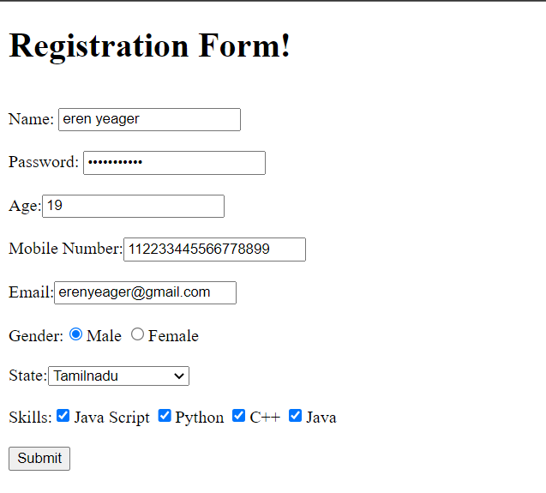

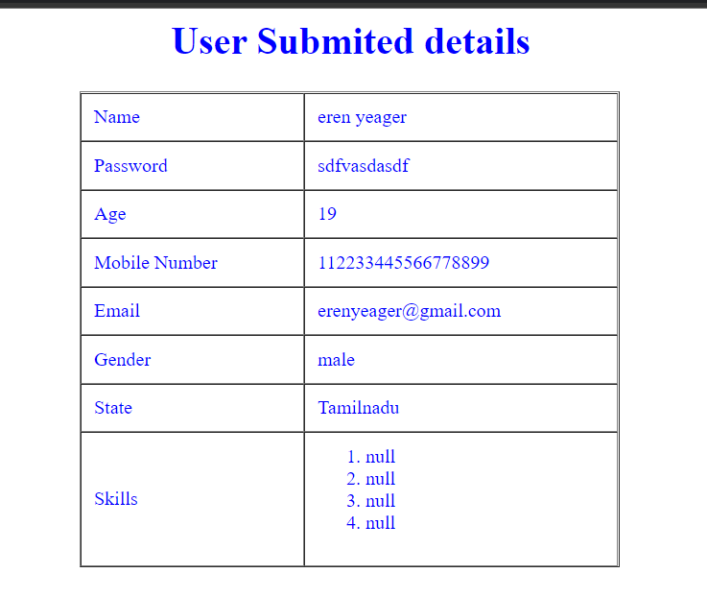

**RESULT:**

The above web page has been created successfully.